**Data Struc & Algor (CIS-277-601HY)**

**Professor Faisal Aljamal  
Timothy Mugyeong Kwon**

**Test II: Dynamic Linked List Project**

**[Menu]**

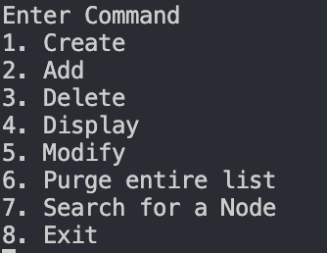

**1. Create**

​**Linked list is** ​**not**​ **created,**​

**a) When a LinkedList is not created, any functions should not be executed.**

[ ​Add​ should not be executed but print the message. ]

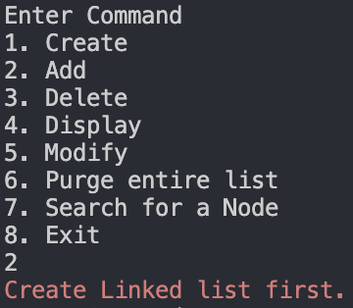

[ ​Delete​ should not be executed but print the message. ]

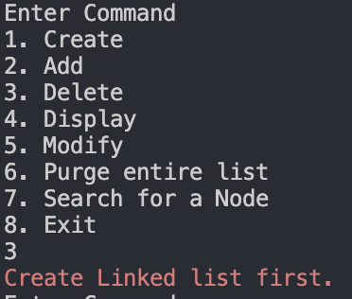

[ ​Display​ should not be executed but print the message. ]

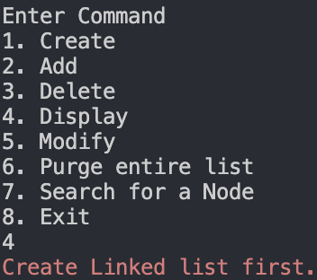

[ ​Modify​ should not be executed but print the message. ]

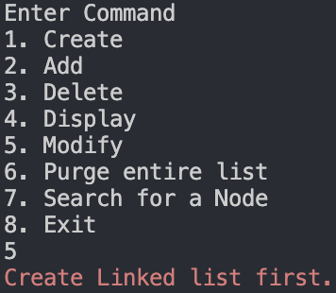

[ ​Purge​ should not be executed but print the message. ]

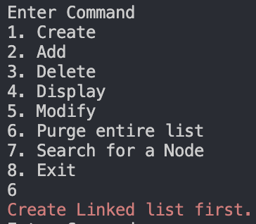

[ ​Search​ should not be executed but print the message. ]

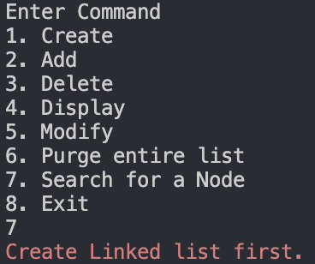

**b) When a linked list is created, the message should be printed. (**​**Checklist 1)**

[ Linked list is created and print the message. ]

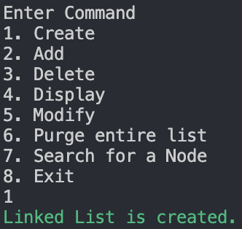

c) **After a Linked list is created, the linked list is still empty,** **So, any functions except Add should not be executed but print message: empty**.

[​Delete​ should not be executed but print the message. ]

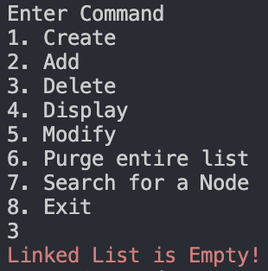

[ ​Display​ should not be executed but print the message. ]

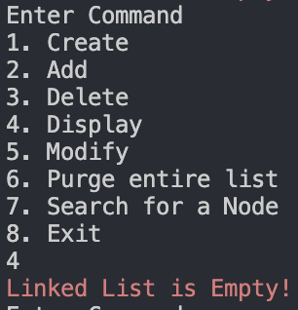

[ ​Modify​ should not be executed but print the message. ]

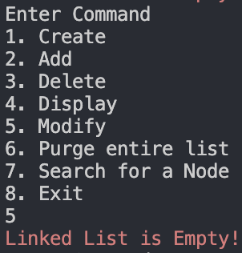

[ ​Purge​ should not be executed but print the message. ]

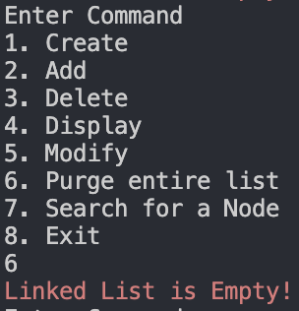

[ ​Search ​should not be executed but print the message. ]

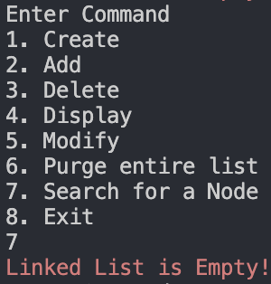

2. Add & Display

● Now Linked list is created. Nodes will be added to the linked list.

a) ​When the list is empty. ​: ​Print the message

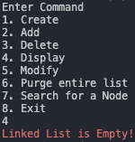

b) ​Checklist 2. Add a node to an empty LL

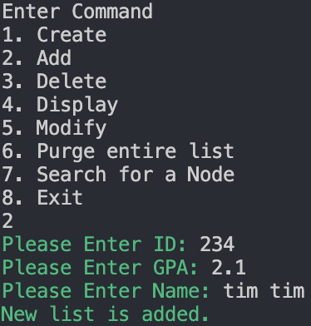

[ Display the linked list to check if the node is added. ]

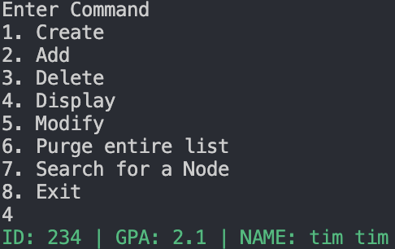

c) ​Checklist 3. Add a node to the front of the LL

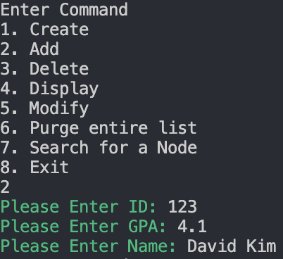

[ Display the linked list to check whether the node is added at the beginning. ]

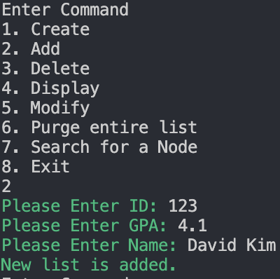

d) ​Checklist 4. Add a node to the end of the LL

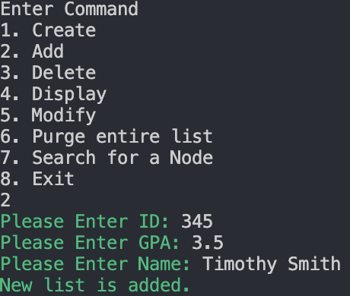

[ Display the linked list to check if the node is added at the end. ]

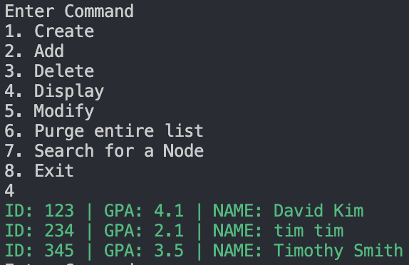

e)​ ​Checklist 6. Add a node to ​somewhere between the first and last​ of the linked list.

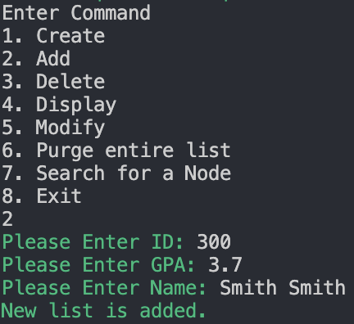

[ Display the linked list to check if the node is added somewhere in the middle. ]

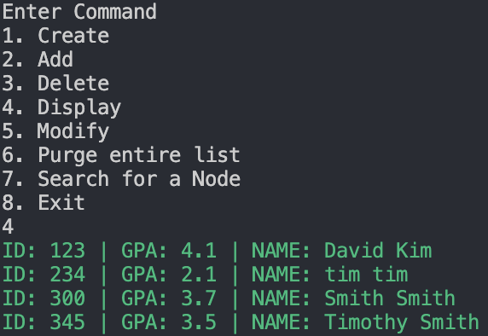

[ Add a new node somewhere between the beginning and the end of the linked list. ]

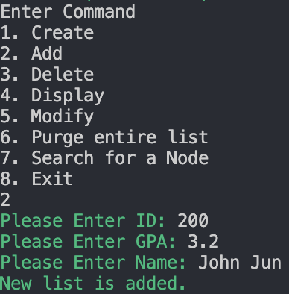

[ Display the linked list to check whether the node is added somewhere in the middle. ]

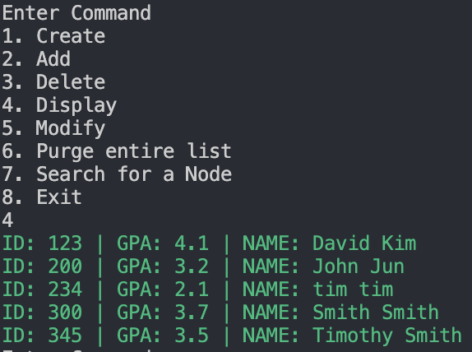

f) ​Duplicated ID should not be added​ and print the message. ​(Checklist 5)

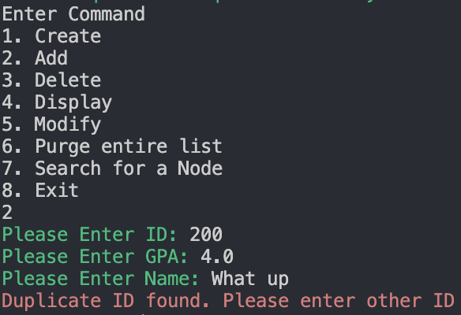

3. Delete & Display

● If the linked list is not empty, the node matching ID will be deleted from the linked list.

a) ​When the list is empty. ​: ​Print the message ​(Checklist 7)

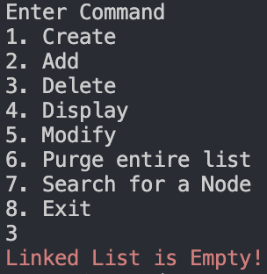

b) ​When the linked list is not empty and has nodes​, display the current linked list.

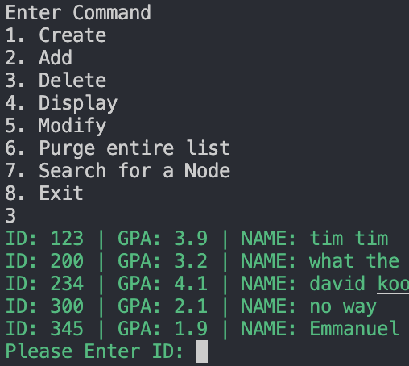

c) ​Delete​ the node ​at the beginning​ of the linked list.​(Checklist 8)

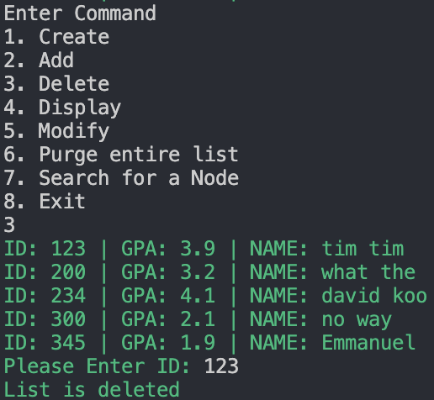

[ Display to check if the node at the beginning is deleted = Yes ]

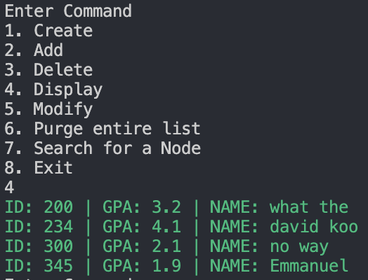

d) ​Delete​ the node ​at the end​ of the linked list.​ (Checklist 9)

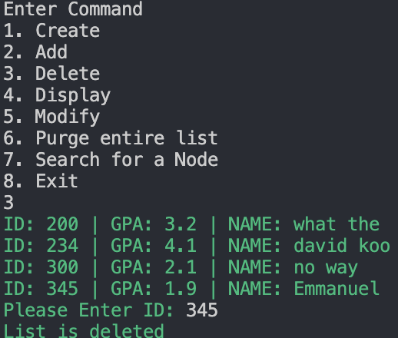

[ Display to check if the node at the end of linked list is deleted = Yes ]

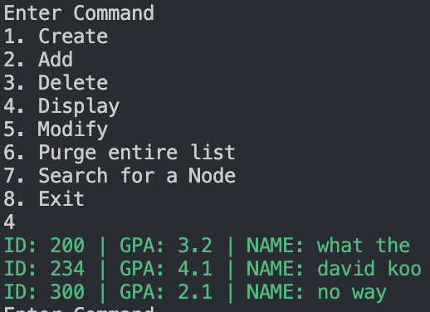

e) ​Delete​ the node ​at the middle​ of the linked list.​(Checklist 10)

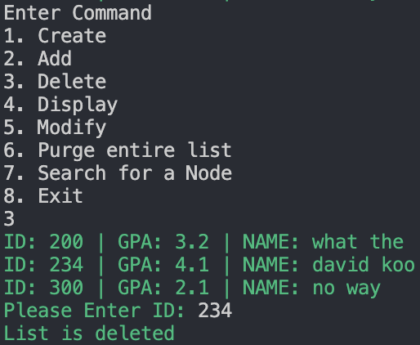

[ Display to check if the node at the middle of the linked list is deleted = Yes]

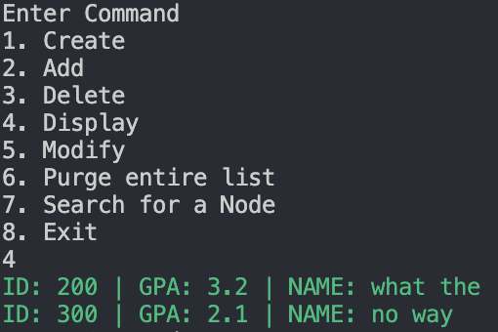

f) ​Not existing ID should not be deleted​ but print the message.

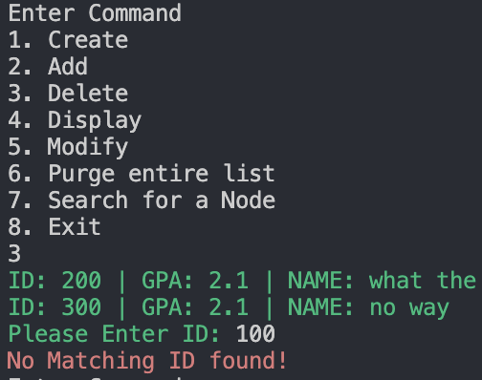

5. Modify & Display

● The node matching with ID will be modified.

[ Display current linked list. ]

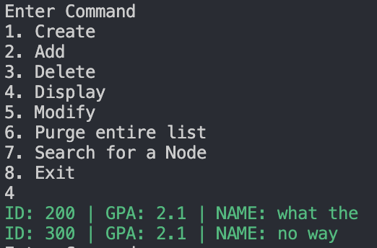

[ Add 4 more nodes to modify the node at the beginning, middle, end of the linked list]

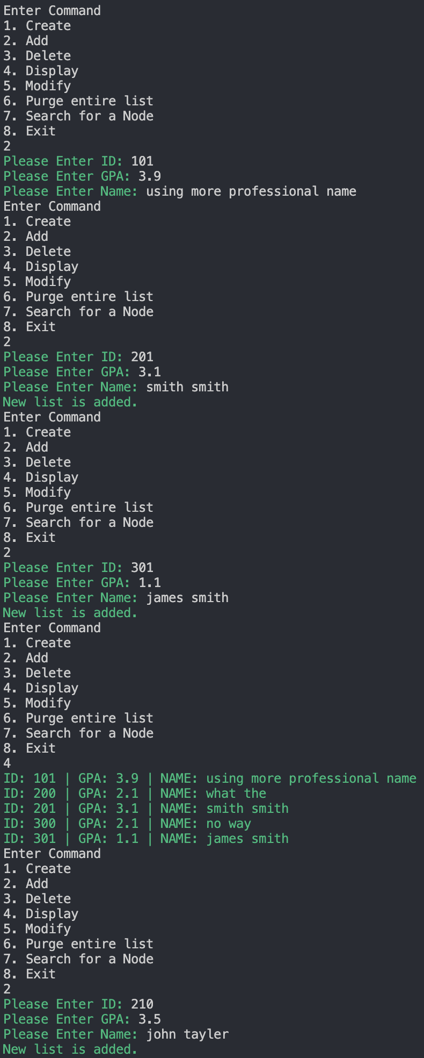

[ Display linked list again with new nodes ]

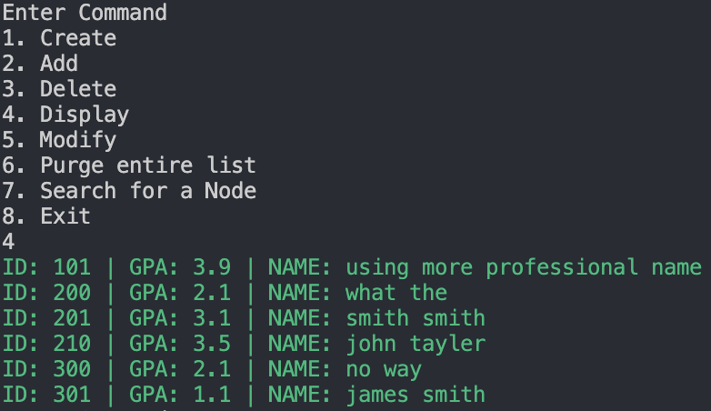

a) ​Modify the node matching with ID​ and ​display the node before and after

modification.​ ​(Checklist 13)

[Modify the ​Front node​ and Display]

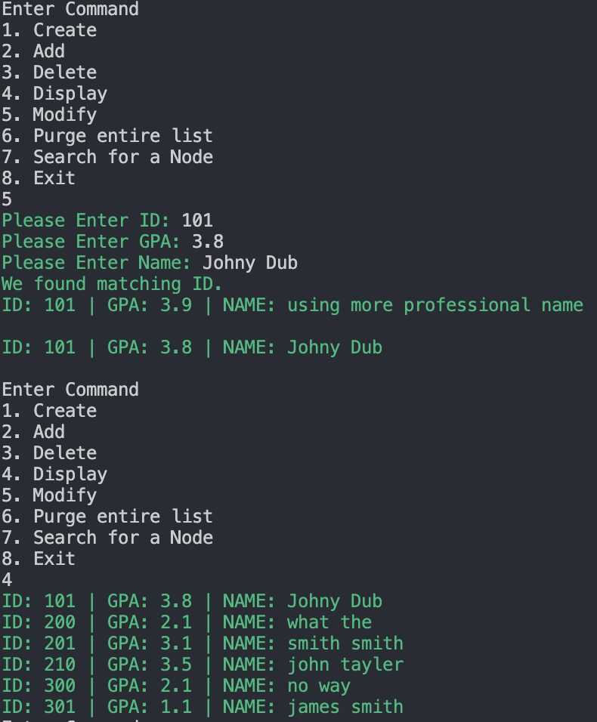

[Modify the ​Middle node​ and Display]

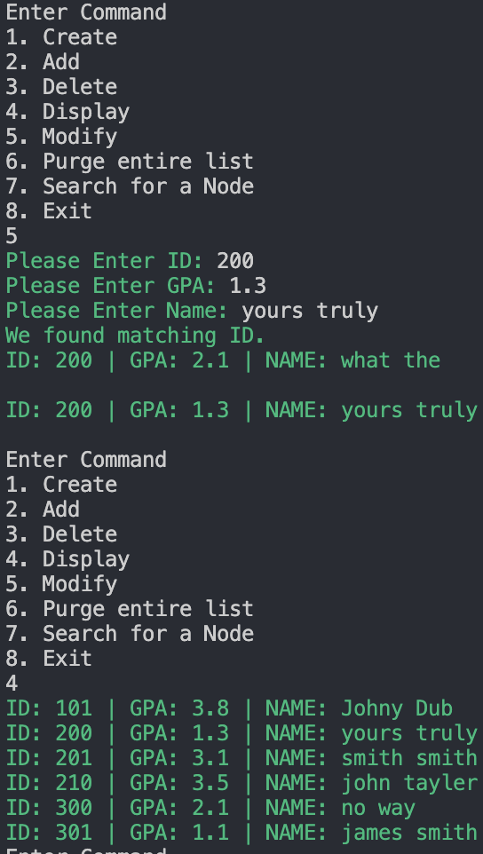

[Modify the ​End node​ and Display]

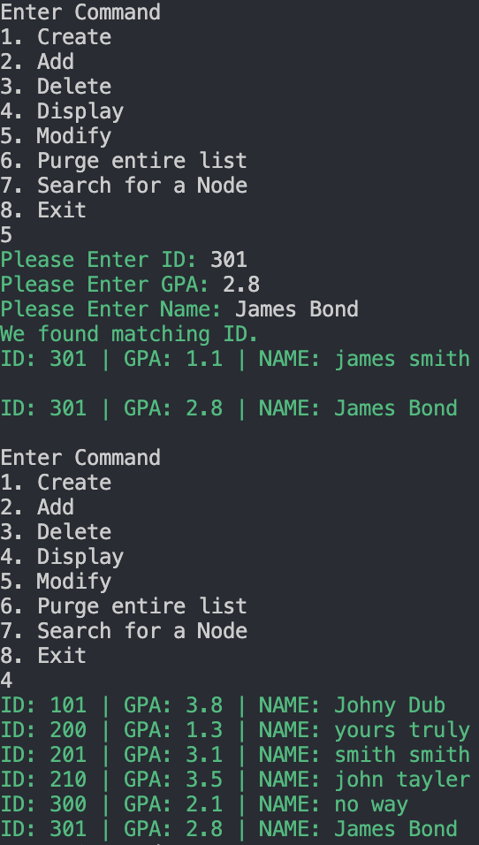

b) ​Not existing ID can not be modified: ​print the message.

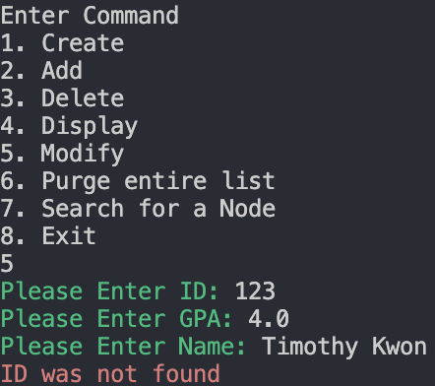

7. Search & Display

● The node matching with ID will be searched and displayed the information in the node. [ Display the linked list. ]

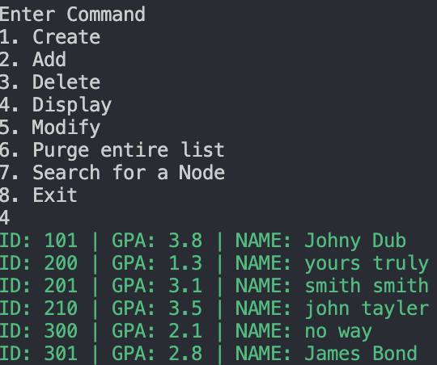

a) ​Search the node matching with ID​ and ​display the information in the node​. (Checklist 11)

[Search the ​Front node​]

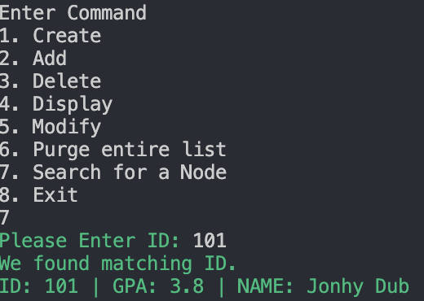

[Search the ​Middle node​]

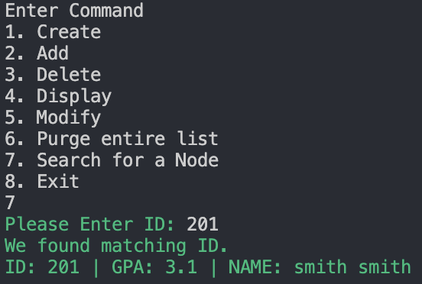

[Search the ​End node​]

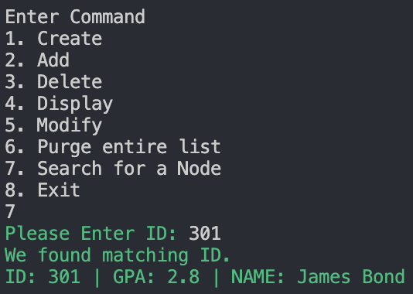

b) ​Search ​not existing ID can not be searched.​ (Checklist 12)

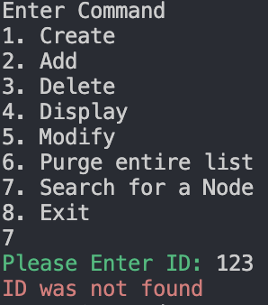

6. Purge & Display (Checklist 14. Purge the LL)

● The entire linked list will be purged.

a) Display and ​Purge the entire list.

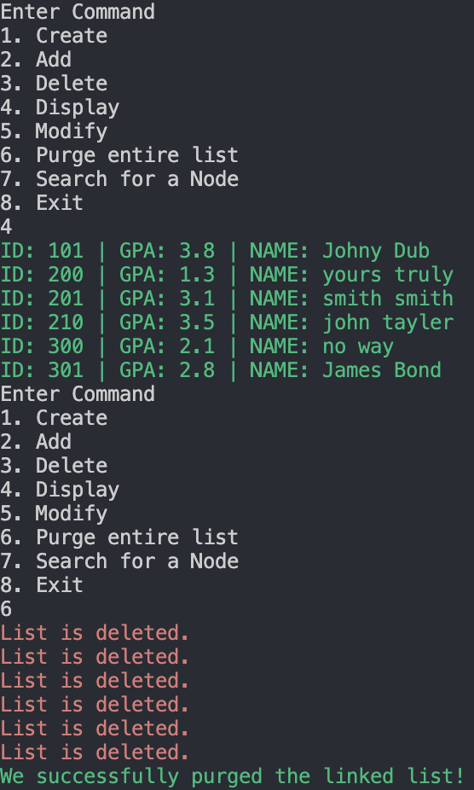

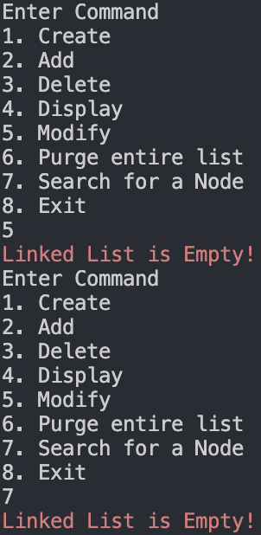 b) ​After purging ​the entire linked list, ​the linked list is empty.

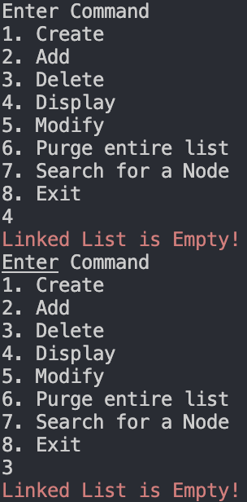

c) ​After purging, if the user chooses “1. Create”,​ it will print the message: ​already created.

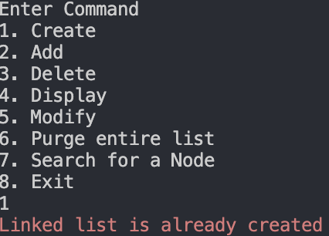

8. Exit

[ Exit the program ]

